GENERAL UPDATES

KAREN REVIEW
rest of state
block groups, etc

UST REVIEW
Colors, etc

MARYA REVIEW
Acknowledgements
Resources
Hi Ellen,
Thank you for this prompt. With the beta version about to go live, I’ve taken a closer look at the tool and have feedback that I probably should have shared earlier. I hope this doesn’t feel like too much given you’re so close to launching the beta version. And of course please take or leave my feedback. I know you’ve taken a very healthy approach in thinking about the tool as iterative. Here’s my feedback on “Other Resources” page:
- Consider slimming “Other Resources” to just “Resources”
- Using the section links at the top of the page, when I click on “Methods” it jumps to “External Resources” instead of to “Methods”
- Please add these 2 new resource categories:
Tree Planting
What trees are predicted to do well in future climate conditions?
  - Climate Change Vulnerability of Urban Trees: Twin Cities, Minnesota
What the best way to plant a tree?
  - Tree Trust video
Connect and Learn
Where can I connect with others working to grow our tree canopy in the Twin Cities or across Minnesota?
  - Minnesota Shade Tree Advisory Committee
  - Minnesota Shade Tree Short Course
- I wonder if the narrative opening could be more succinct. Here’s an idea:
  - Growing Shade is a unique tool that highlights stories and offers users the ability to consider how they prioritize this important work of growing and maintaining our urban tree canopy. This tool is under active development, so please check back or contact us for more details. (Provide contact info)
There are many additional tools and resources that may be useful to you. We’ve compiled the list below as a starting point.
Finally, when planning and prioritizing urban forestry work, tools and data cannot substitute for stakeholder engagement to understand community-specific concerns or opportunities. The on-the-ground knowledge of residents and the expertise of local practitioners are valuable sources of information.
I also have some thoughts on other aspects of the tool if that’s ok:
- The site takes some time to load. Are there ways to make it faster or is there just so much content?
- On the Home page, there’s a lot of space between sections as you scroll. Can that be tightened up at all?
- On the Home page, the tabs just below the title (Welcome, Using the tool, etc) is in pretty small font. Can that be enlarged a little and/or bolded?
- I think the point you make on the Other Resources page that data cannot substitute for community engagement is SO important. Can you also include that language (or something like it) at the bottom of the Welcome section?
- In the “Using the tool” section, you outline the two parts of the tool: “Learn and listen” and the “Mapping tool” but then the next white section is just called “Learn” – do you want it to be “Learn and listen” for consistency?
- In the “Learn” section, I love that you outline the stories that will be highlighted below. I wonder if you can be clear that this section is about stories even more by adding “through stories” at the end of the first sentence.

KRYSTEN REVIEW

Structure / IA Overall

Unfortunately, I think the StoryMap embedded in the Shiny tool is somehow less than the sum of its parts.
- Visually, the “frame” that the Shiny app holds around the visuals of the StoryMap takes me out of the immersive high-impact visuals that are the strength of that platform. There is also too much white space in some places and the toggling of the text on the right/left makes scrolling and scanning the content much harder.

- Functionally, I see only two areas where the StoryMap is adding features
  - Navigation bar across the top
  - Three slider maps (two of which don’t require/solicit interactivity, the last/third of canopy + heat is in the tool)
Thank you for pointing out the use of the slider maps. Specific to the land surface temperature (heat) and tree canopy overlay, we prefer to keep the connection between to two very obvious. Indeed, information about tree canopy does lie within the extreme heat tool, but two key advancements are being made by separating it here
- users can’t find the tree canopy; based on trainings, etc
- the tree canopy is 2015 vintage in the tool, here we are using 2021 (eab has significantly changed things, etc)

- Storytelling, there is too much ground being covered here – I wasn’t sure if there are other text changes planned, but I have a document with edits available if you’d like. Will mention one thing: Please consider “Priority/ies” instead of “prioritization”. It’s a use/utilization thing – why use a 10-cent word when 5 will do?
- Something about “tree canopy prioritization” already being a forestry word

No issues with the *structure of the Shiny app; it is aligned with our general approach at this time. Though I would rename the “Other Resources” tab to “Resources & Methods”.

StoryMap
- As-is, the StoryMap is a potpourri of instruction, issues, examples – it just doesn’t “build” as an explanatory/coherent piece. Its framing this in our eyes (deliverables of a project) versus user-centered way.
- Really, I would pull almost all of this content – especially the case studies – out of this tool and bring them into a web page, along with project background. Instead, focus the first tab of the Shiny app on How to Use, by hosting the video and user guide there/upfront. This is the heftiest suggestion.

- If you stick with StoryMap embed:
  - Remove the image and title from the Shiny app; just start with the StoryMap, and add the title/image section there. This will smooth out the information hierarchy.
  - In addition, strongly suggest a parallel structure to use across examples/stories. Maybe a “slide show” format on each, or something that allows both the images and text to shine. Right now it looks more like a web page, which is why I think it should just be one.
  - Remove “Using the tool” and “Learn” sections. There isn’t enough detail or demo-value here to be helpful. Retain & move some of the text to neighboring sections.
    - Optional: if you can’t live with removing this completely, consider adding a section AT THE END, that pulls in the user guide video directly, links to the user guide.
    - The “Learn” section is particularly tough; I completely missed the legend the first time (oddly at bottom left corner!) There is also no information on what the different concepts in the Prioritization Layer are at that point, so I cannot make sense of it.

Some specific suggestions…
  - Frogtown Green/all case studies. I understand why this labeled “Equity” at the top (character limits of these titles) but it comes across disconnected unless/until you read through the content here, which not everyone will do. Consider, “Priority: Equity” or some similar schema that better connects these.

  - The slider maps between Saint Paul neighborhoods requires a lot from a user – you have to open the legends to understand what you’re seeing and the formatting of the legend units is lacking (in GIS). Also slightly confusing because the tree data is at block? Block groups? And the demographic data at census tract level, so the “slider” motion is not a 1:1, which is its strength. Lastly, there isn’t much reason to “interact” here, the tool tip should be removed.
  - There is a compelling paragraph that essentially unpacks/summarizes the connection to equity; it ticks through several data points the correlate with low tree canopy (low income, residents of color, etc.) I suggest four static maps of those characteristics + a tree canopy; perhaps really zoomed into Frogtown or city-wide with a highlight on Frogtown, all combined into one image and have that paragraph as a scrolling text / sidecar. This will *highlight* the connection to equity, something that I can easily miss/scroll past now.

  - At the very least, writing a clearer caption here could help. Rather than “Swipe to see the relationship between tree canopy and race.” just tell people (again) what that relationship is, “In Saint Paul’s communities of color (shown right), the tree canopy is often thin/thinner (shown left).” More descriptive, less instructive – the latter should be intuitive. Try to format the legend units/text, and do not use acronyms like “BIPOC” – spell it out.

  - The “Using the Mapping Tool” paragraph and image feel tacked on here. A section, as described above, that has the video, and maybe a “slide” on each of the priority layers and how to explore those in the tool with full-sized images would be more effective. I can’t even read the text in this image.

- Lower Phalen Creek Project (& throughout StoryMap) - text on left. Do not toggle!
  - This is where I’m really missing visual impact. I cannot read the text in the diagram.
- Washington Conservation District
  - Again, sliders could be large, static side-by-sides.
  - Cannot read the small diagrams, even when I click on them.
  - Linked text should be formatted to denote that (beyond an outline). We use same technique as on the website (blue, bolder + underline)

- Brooklyn Center Community Schools
  - The tree canopy + heat map feels tacked on here; only connecting with a single sentence about the playground temp. This section could be reworked to connect with the “Climate Change” priority?

- Tree Trust
  - Again, small images with illegible text.
  - The lede is buried here; lots of interest in EAB and other pest data at scale; could we better highlight this?

- Taking Action
  - I wouldn’t describe this in terms of “deliverables of a project” (!!) I think this section needs some work – actions beyond making a custom report from our tool. What other TA is available? More levers of change or remove section.

Mapping Tool

- Suggest renaming this tap; “Build a Tree Canopy Report” or some such. It’s more than mapping!
- Strongly suggest including the descriptions of the Prioritization be included right in the tool, not just in the “info” pop-up.

- In the priority pop-up, use a symbol – not the word “included” and sort by the option that has the longest list. This is hard to read as-is.

- The Custom Report section could benefit from some help/hierarchy of info; the select a tract/map vs select city or neighborhood is a little clunky; maybe not much can be done here. However, I think two buttons are totally lost/floating here, and one should come at the *bottom* of the report, so you understand that THIS is what you’re downloading. Also, the data download; what I think has worked really well is the html-tagged table that Liz baked into Metro Rent Trends… you see what you’re going to get/data before you download it (+ its web accessible). I would make the Download Data its own tab within the Shiny App, include that table + download option there. If you want to include a link to that over here, great! Under “neighborhoods” … clarify that only Minneapolis and Saint Paul neighborhoods are included.

- Growing Shade report

  - Remove all (errant) colons!
  - I understand there was a debate about this in the census app; but I think the box-whisker plot is just tough/overkill. Hard to interpret (y’all wrote a explanatory info pop-up, so you do understand that?) Can we please please rethink this (everywhere)? A simple numeric ranking alongside a chart of actual values would be much quicker to understand – too much erroneous info compared to the essential piece (I think users want to know the actual value; THEN the context.)

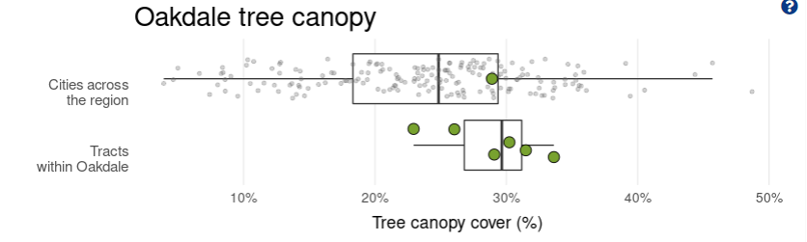

- Here again, so confused. Drop this chart, go with table you have but also label the priority + data points. Include a clear explanation of what these score mean (don’t leave this in the info pop up).
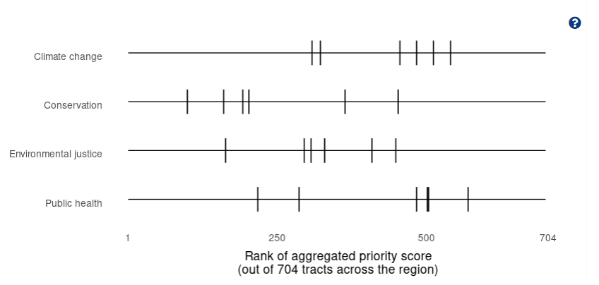
- Equity section
  - Same comments I offered on slides a while back; no vertical text, I’d add 10-20% more to your Y axis for some breathing room (values creep very close to top); no acronyms, us the actual dollar values, don’t make folks do the math on thousands. Include sources with a year (ACS?). Remove A & B. Have axis lines.
    - “Share of tree canopy by median household income” as the header, for example.
  - Would really prefer to see % of specific race/ethnicity groups based on user selection versus group all POC together. We also have several income measures that folks may want to choose from versus median income. Equity can mean letting users drive more of this sub-analysis.
- Rename “threats” ? – that is what they are! But something more direct, “Pests, Biodiversity, Other”.. For a second I thought there was a SWOT analysis in the mix.

- Same Q about thinking about binning Low/Med/High priority values in the map and stepping those colors.

- MUST add a source/footnote to bottom of report in the app, something like “This data was provided by The Growing Shade project, a collaboration of XYZ. Data sources and methodology available at X. Data are current as of (timestamp).”

- At the bottom of map, I would include a dynamic caption (based on what is being shown) and a text + image that points out that little layer button and what is in there. Very easy to miss this.

- Lastly (WILL IT EVER END) Will the html report spit out something I can see before downloading? Will the content be accessible?

